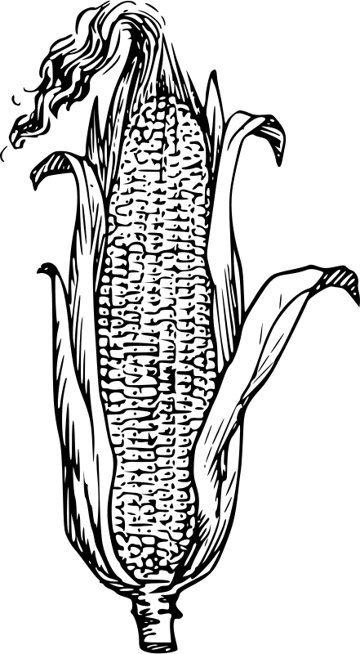
Good Works, Inc.
2017 Teen Agricultural Internship
June 19th to August 3rd

The Good Works Teen Agricultural Internship is an opportunity, open to local teenagers between the ages of 14-17, to work with Good Works staff, volunteers and interns on agricultural projects at various locations in Athens County. The Teen Ag. Internship is as much about character development as it is about service. In addition, interns will take part in daily discussions about sustainable agricultural techniques, crop identification, soil health, livestock, disease prevention/treatment and food insecurity in our region.

In addition to developing and maintaining agricultural projects on Good Works properties, interns will work alongside Good Works staff to start and maintain community gardens at the homes of our friends and neighbors here, in Athens County. Many of the people the Teen Ag Interns will meet and work alongside are struggling with the effects of aging, disability and/or poverty. The Good Works agricultural initiative, called Good Works Gardens, is dedicated to the mission of helping our neighbors provide healthy food for themselves and their families.

It is our hope that through this experience each intern is given the opportunity to experience personal growth in the following areas: leadership, teamwork, a healthy work ethic and general agricultural know-how. Upon completion of the internship, each participant will receive a $300 stipend. The Teen Ag. Internship will meet on Mondays, Tuesdays and Thursdays beginning on June 19th and ending on August 3rd. Interns will be expected to arrive at 8am to begin the workday, which will end promptly at 4pm.

Good Works, Inc. is a faith-based non-profit focused on loving and serving our neighbors struggling with poverty in southeast Ohio. Good Works was established in 1981. January marked the start of our 36th year! For more information or to receive an application for the Teen Agricultural Internship, contact Doug Schmaltz by phone at 740.594.3339 or email: goodworks@good-works.net
